<Facility Usage Module> by <Faith Goh Kim Ling>

4.1.1 Brief Description

There are 4 main function in this module which is Add Facility Usage function, Modify Facility Usage function, Display Facility Usage function and Search Facility Usage function.

Add Facility Usage Function

User can enter user ID. If the ID that user enter found, the system will display the facility usage details. After that, user can choose whether want to walk in booking or online booking. After select choice, user required to enter the time they want to walk in or online booking. Then the system will ask user what is the next step they want to do. The user can press ‘1’ to back menu to continue facility usage module or ‘3’ to stop looping.

Search Facility Usage Function

User can enter the searched user ID into the system that they want to search.The system will display the facility usage details record founded in the system which is facility ID, facility name, booking date, and booking time that user searched. The system also show that which booking was chosen in the facility usage. It will display choice chosen which is walk in booking or Online booking, and also the booking time. The system record founded in the system. The user can press ‘1’ to back menu to continue facility usage module or ‘3’ to stop looping.

Display Facility usage Function

The system will display the facility usage information that already recorded in the system. Then, the facility ID, facility name, user ID, booking date and the booking time, what type of booking and also the time set by will displayed on the screen. The user can press ‘1’ to back to facility usage menu or ‘3’ to exit this function.

Modify Facility Usage Function

The system will ask user whether want to modify facility ID, facility name, user ID, booking date or booking time. After user select their choice, user will require to enter the facility ID, booking date and booking time of the booking they want to edit. If the three information matched, user can enter the new details they want to modify. After enter new details, the modify was successfully proceed. At last, system will ask user want to back to menu or exit.

4.1.2

a)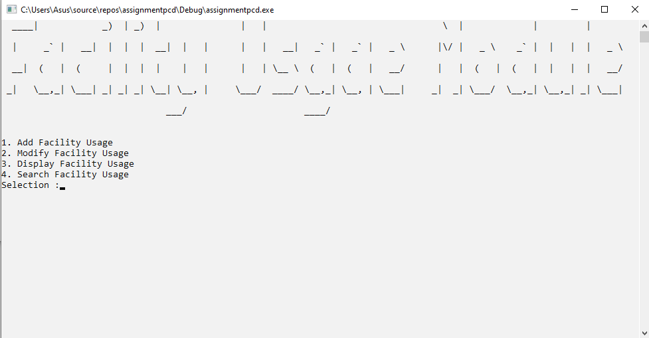

1) Main menu that display 4 function which is add facility usage function, search facility usage function, display facility usage function and modify facility usage function.

b)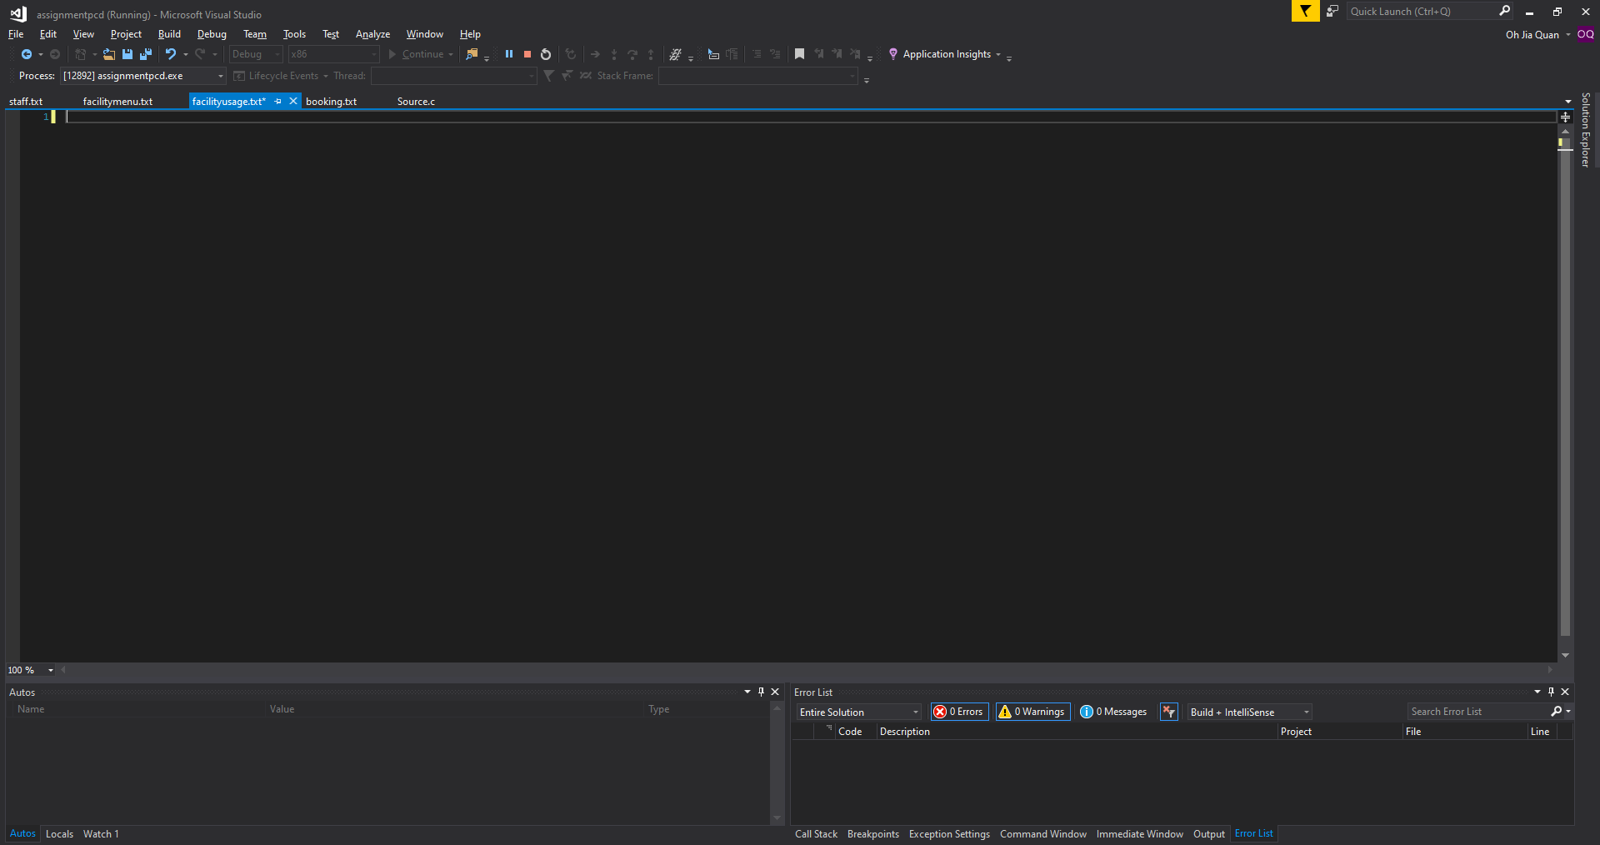

c)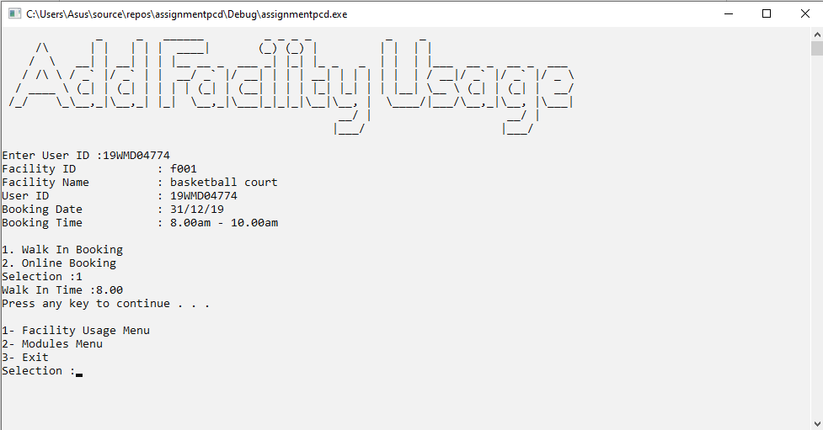

1) Enter user ID  
2) The system will display all details.  
3) Select you choice, walk in booking or online booking.  
4) After select, enter the time you want.  
5) The facility usage is already confirmed.

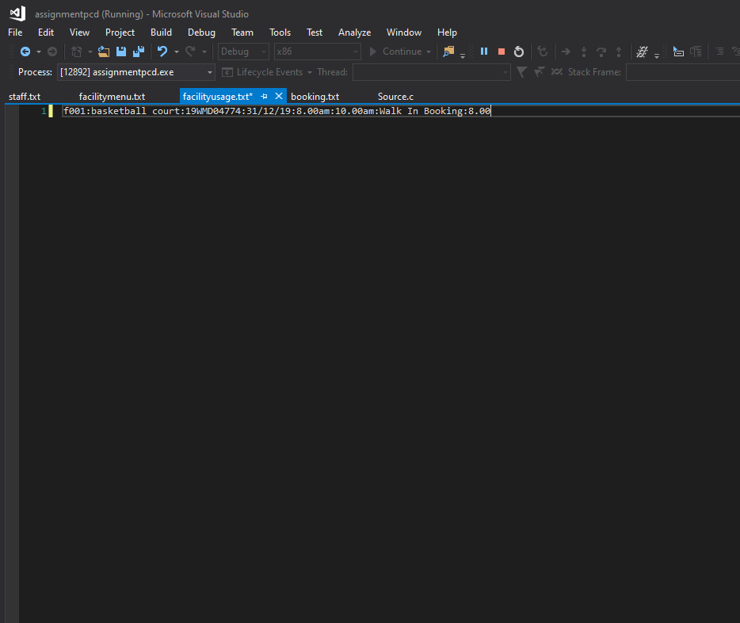

d) 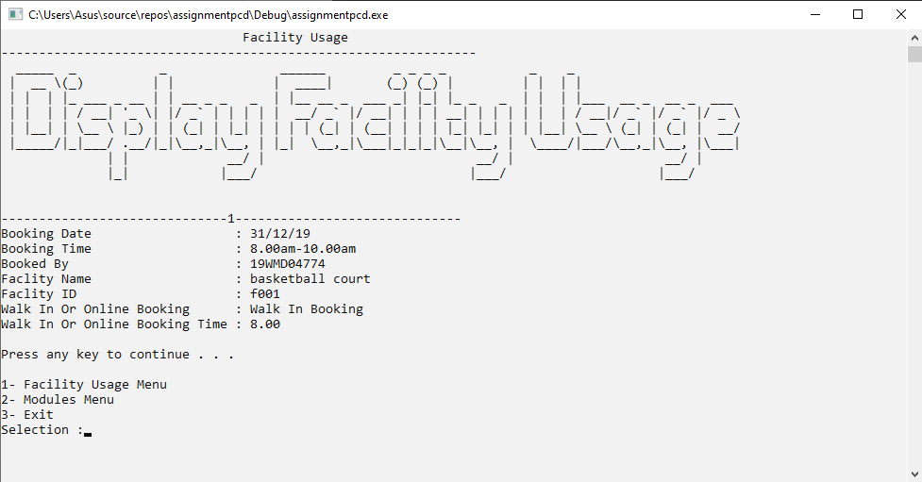

1)This is display facility usage function.

2) User can back to menu by enter ‘1’ or ‘3’ to exit.

e)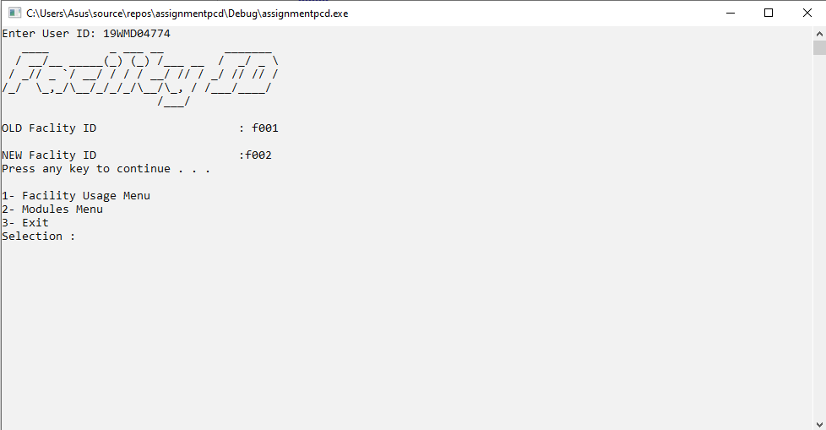

1)This is modify facility usage function to modify facility ID.

2)User required to enter user ID.

3)If found,the system will display the old facility ID.

4)User now can enter new facility ID.

5)User can back to menu by enter ‘1’ or ‘3’ to exit.

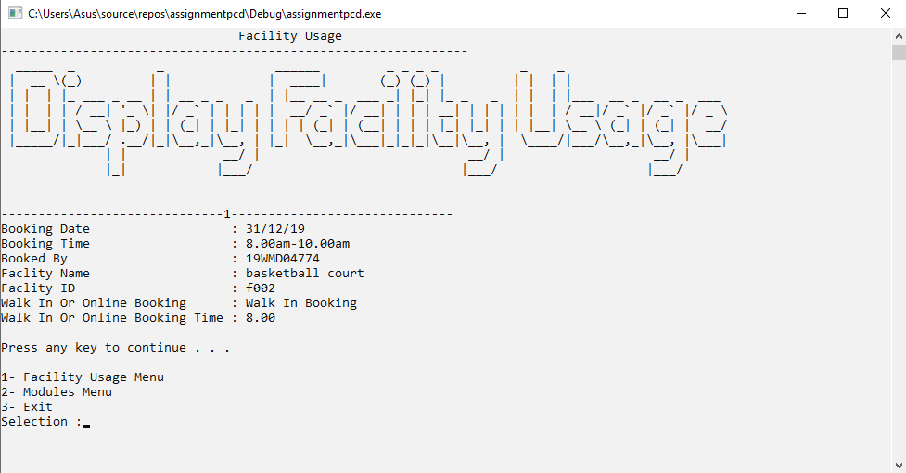

f)

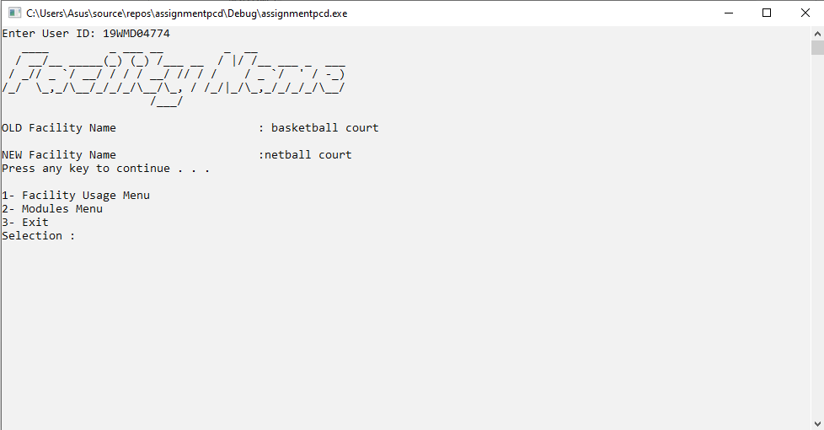

1)This is modify facility usage function to modify facility name.

2)User required to enter user ID.

3)If found, the system will display the old facility name.

4)User now can enter new facility name.

5)User can back to menu by enter ‘1’ or ‘3’ to exit.

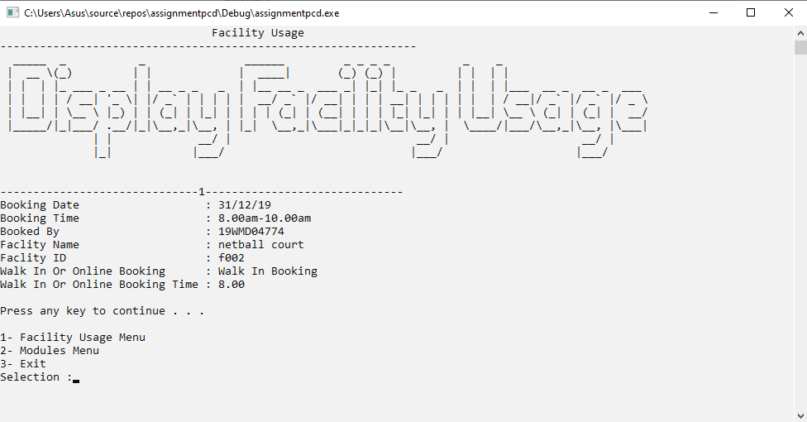

g)

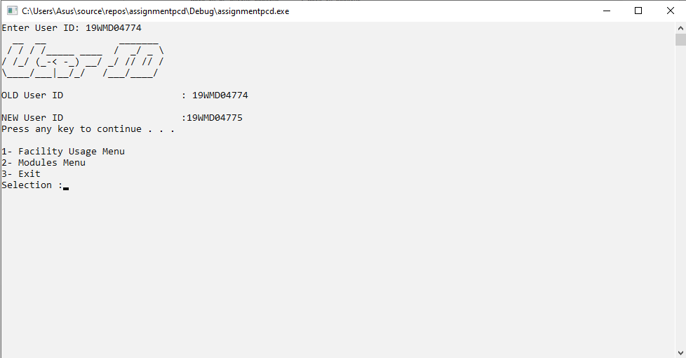

1)This is modify facility usage function to modify user ID.

2)User required to enter user ID.

3)If found, the system will display the old user ID.

4)User now can enter new user ID.

5)User can back to menu by enter ‘1’ or ‘3’ to exit.

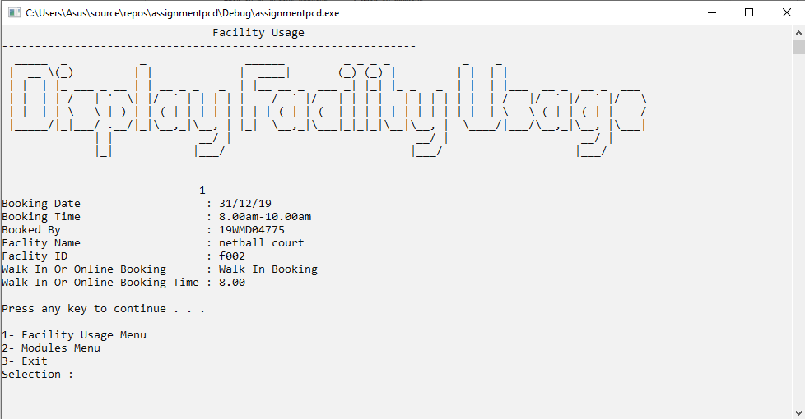

h)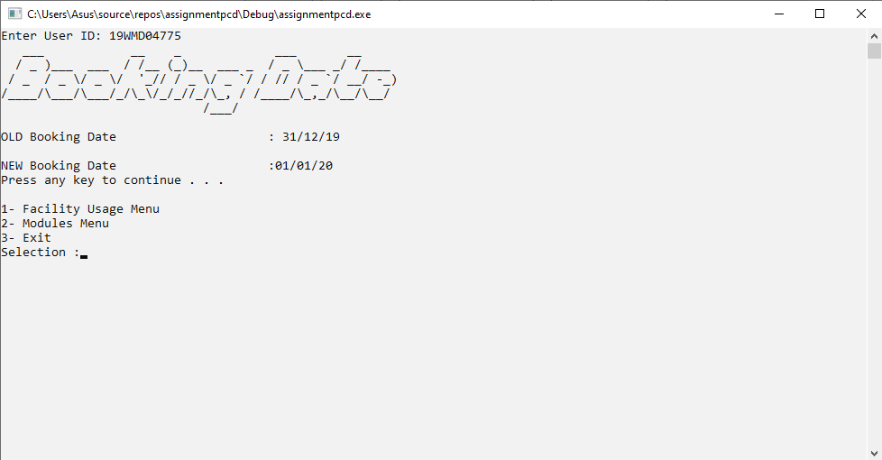

1)This is modify facility usage function to modify booking date.

2)User required to enter user ID.

3)If found, the system will display the old booking date.

4)User now can enter new booking date.

5)User can back to menu by enter ‘1’ or ‘3’ to exit.

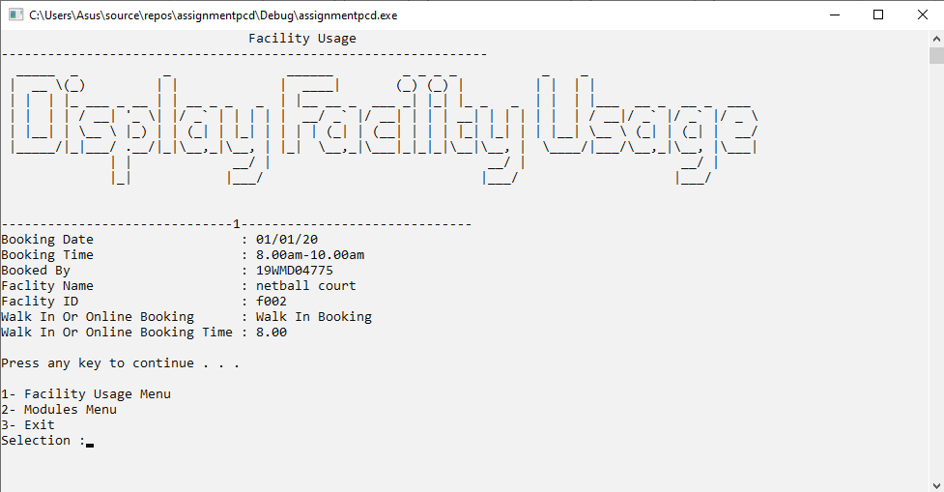

i)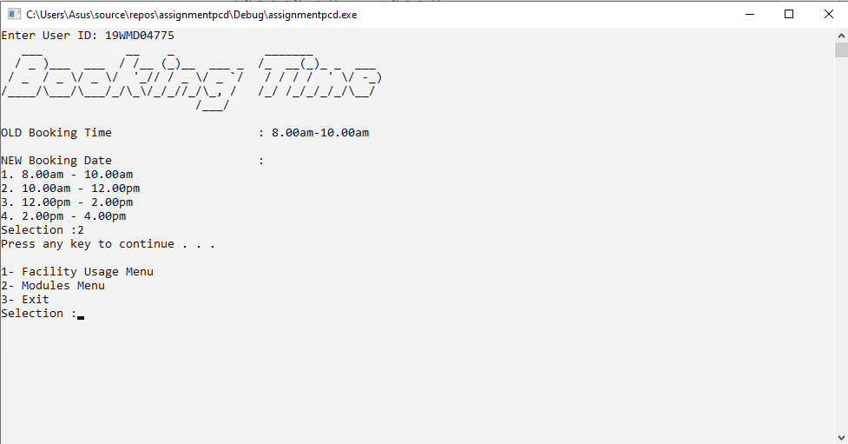

1)This is modify facility usage function to modify booking time.

2)User required to enter user ID.

3)If found, the system will display the old booking time.

4)User now can choose the new booking time.

5)User can back to menu by enter ‘1’ or ‘3’ to exit.

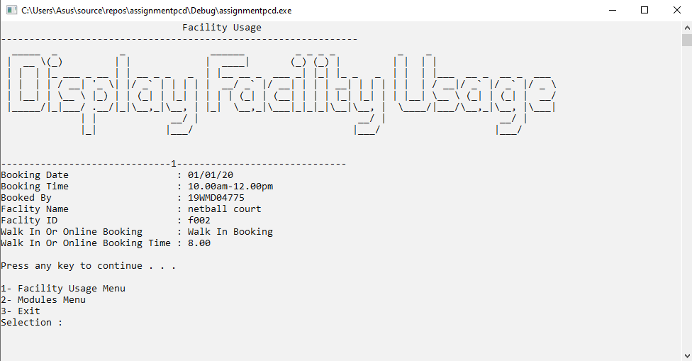

j)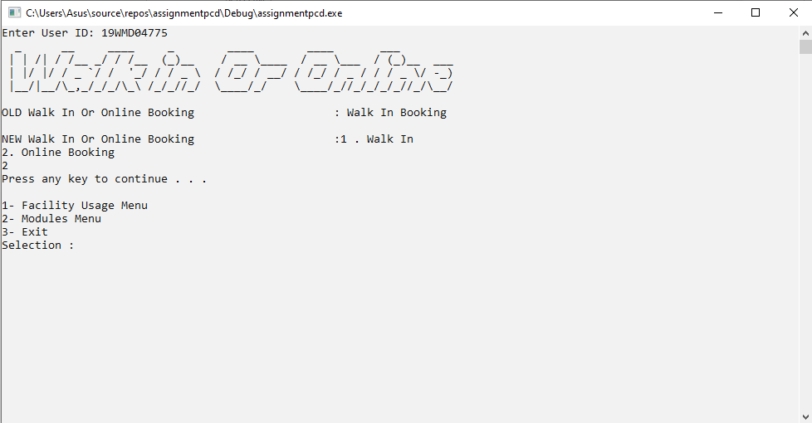

1)This is modify facility usage function to modify booking choice.

2)User required to enter user ID.

3)If found, the system will display the old booking choice.

4)User now can choose the new booking choice.

5)User can back to menu by enter ‘1’ or ‘3’ to exit.

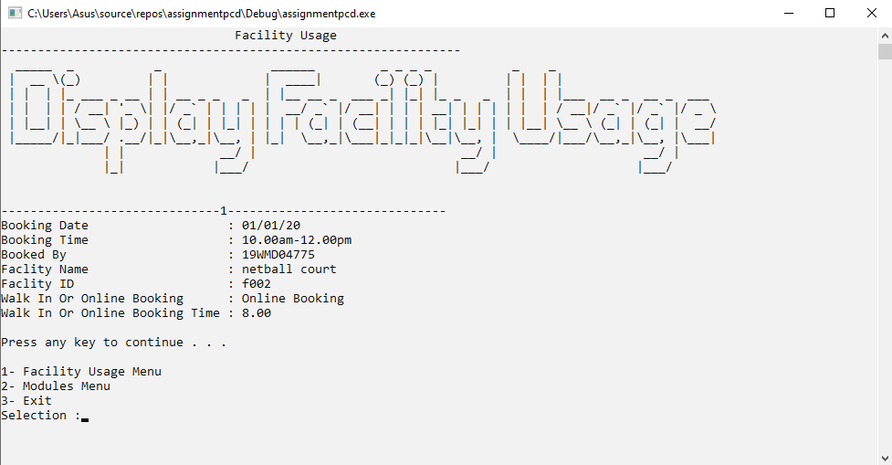

k)

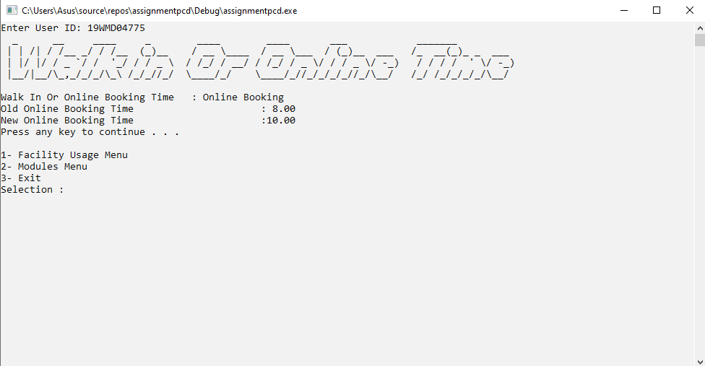

1)This is modify facility usage function to modify booking choice time.

2)User required to enter user ID.

3)If found, the system will display the old booking choice time.

4)User now can enter the new booking choice time.

5)User can back to menu by enter ‘1’ or ‘3’ to exit.

